**Process flow of userDetailsQuora.py**

|  |
| --- |
| Note –  1. In case the user has the first as well as the last name, Quora maintains it as a string separated with ‘-‘.  2.If there are multiple users with the same name, the name string is appended with numbers, in order, starting with 1 |

Program execution starts with invoking the python script.

1. The user is asked to enter the option.



1. If the user knows the exact profile name of Quora member, they can hit 1. The control goes to the point where the user is asked to enter the profile name. The input should be as per the standard of Quora naming policy.

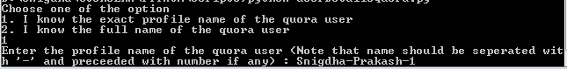

1. The processing starts and it gives the basic stats of the profile.

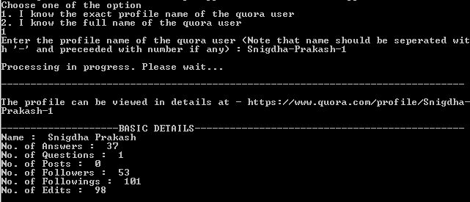

1. If the user doesn’t know the exact profile name of the Quora member, instead knows the full name, he can enter option 2. The control goes to the point where the user is asked to enter the full name of the Quora member.

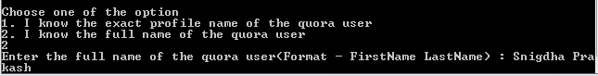

1. The processing starts. However there are 3 members with this name. The script searches for the all the quora members and display the option for the user to choose.

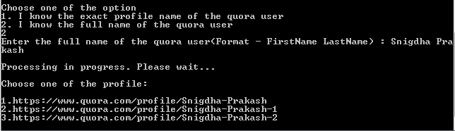

1. The user decides and hits an option, say 2, the script immediately pulls the details from the website and displays it.

